**Write a menu driven program in C to create a structure employee having fields empid, empname, salary. Accept the details of 'n' Employees from user and perform the following operations using function.**

#include<stdio.h>  
#include<stdlib.h>  
struct details  
{  
     char name[30];  
     int eid;  
     int salary;  
}emp[5];  
void emp_search(int r)  
{  
     int id,i;  
     printf("\nEnter Employee-Id to be Searched : ");  
     scanf("%d",&id);  
     printf("----------------------------------------\n");  
     for(i=0;i<r;i++)  
     {  
          if(emp[i].eid==id)  
          {  
               printf("Employee Id : %d",emp[i].eid);  
               printf("\nName        : %s",emp[i].name);  
               printf("\nSalary      : %d\n",emp[i].salary);  
          }  
     }  
}  
void display(int r)  
{  
     int i;  
     printf("\nList of All Employees:\n");  
     printf("-------------------------------\n");  
     printf("Emp-Id\tEmp-Name  Salary\n");  
     printf("--------------------------------\n");  
     for(i=0;i<r;i++)  
     {  
          printf("%d\t%s\t  %d\n",emp[i].eid,emp[i].name,emp[i].salary);  
     }  
}  
void greater(int r)  
{  
     int i;  
     printf("\nDetails of Employee Whose Salary > 10000\n");  
     printf("------------------------------------------------");  
     for(i=0;i<r;i++)  
     {  
          if(emp[i].salary>10000)  
          {  
               printf("\n Employee Name : %s",emp[i].name);  
               printf("\n Employee-Id   : %d",emp[i].eid);  
               printf("\n Salary        : %d\n",emp[i].salary);  
          }  
     }  
}  
int main()  
{  
     int n,i,ch;  
     printf("/*How Many Employee Record You Want to Add*/\n\nEnter Limit  : ");  
     scanf("\n %d",&n);  
     for(i=0;i<n;i++)  
     {  
          printf("-----------------------------------------");  
          printf("\n\tEnter Details of Employee-%d",i+1);  
          printf("\n-----------------------------------------");  
          printf("\nName of Employee : ");  
          scanf("%s",emp[i].name);  
          printf("Employee-Id      : ");  
          scanf("%d",&emp[i].eid);  
          printf("Salary : ");  
          scanf("%d",&emp[i].salary);  
     }  
     while(1)  
     {  
          printf("-----------------------------------------\n");  
          printf("\t\tMenu\n");  
          printf("-----------------------------------------");  
          printf("\n 1:Search Employee by E-ID");  
          printf("\n 2:List of All Employee");  
          printf("\n 3:Display Employee Name whose Salary > 10000 ");  
          printf("\n 4:Exit");  
          printf("\n----------------------------------------\n");  
          printf("Enter Your Choice : ");  
          scanf("\n %d",&ch);  
          switch(ch)  
          {  
               case 1: emp_search(n);  
               break;  
               case 2: display(n);  
               break;  
               case 3: greater(n);  
               break;  
               case 4: exit(0);  
          }  
     }  
     return 0;  
}

**Output-1**  
  
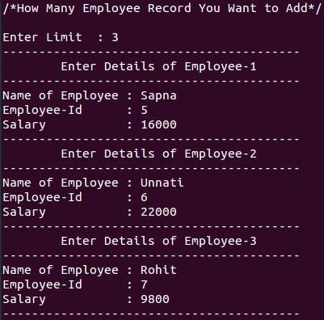  
  
**Output-2**  
  
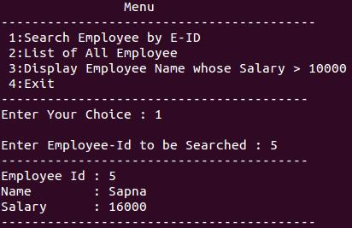  
  
**Output-3**  
  
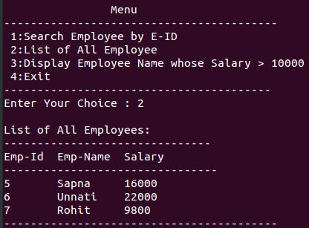  
  
**Output-4**  
  
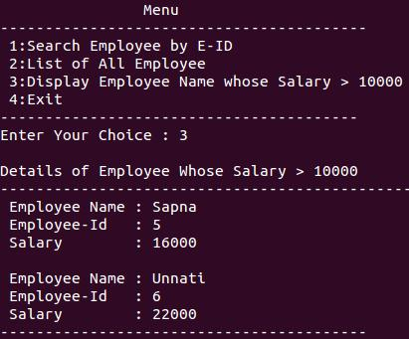

**Write a C program to create a student structure having fields stud_name and address. Accept the details of 'n' students, rearrange the data in alphabetical order of student name and display it.**  
  
**Solution:**

#include<stdio.h>  
#include<string.h>  
struct stud  
{  
     char name[50];  
     char add[50];  
}s[100];  
int main()  
{  
     struct stud t;  
     int i=0,j=0,n;  
     printf("/*How many student records you want to enter?*/");  
     printf("\n\nEnter Limit : ");  
     scanf("%d",&n);  
     for(i=0;i<n;i++)  
     {  
          printf("\\nEnter Student-%d Details",i+1);  
          printf("\n--------------------------\n");  
          printf("Enter Name     : ");  
          scanf("%s",s[i].name);  
          printf("Address        : ");  
          scanf("%s",s[i].add);  
     }  
     printf("\n\tData before rearrangement");  
     printf("\n-----------------------------------\n");  
     printf("Student Name\tAddress\n");  
     printf("--------------------------------------\n");  
     for(i=0;i<n;i++)  
     {  
          printf("\n%-10s\t%3s\n",s[i].name,s[i].add);  
     }  
     for(i=0;i<n;i++)  
     {  
          for(j=i+1;j<n;j++)  
          {  
               if(strcmp(s[i].name,s[j].name)>0)  
               {  
                    t=s[i];  
                    s[i]=s[j];  
                    s[j]=t;  
               }  
          }  
     }  
     printf("\n\tData after rearrangement");  
     printf("\n-----------------------------------\n");  
     printf("Student Name\tAddress\n");  
     printf("--------------------------------------\n");  
     for(i=0;i<n;i++)  
     {  
          printf("\n%-10s\t%3s\n",s[i].name,s[i].add);  
     }  
     return 0;  
}

**Output-1**  
  
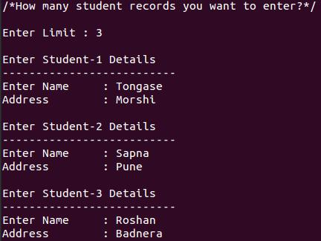  
  
**Output-2**  
  
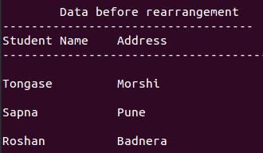  
  
**Output-3**  
  
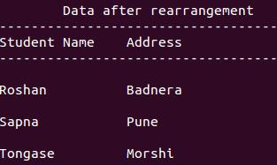

**Write C program to accept the details of employee and display them using structure. Details consist of Employee ID, Name, Designation, Department, Salary.**  
  
**Solution:**

#include<stdio.h>  
struct employee  
{  
     int e;  
     char name[20];  
     char designation[20];  
     char dept[20];  
     int sal;  
};  
int main()  
{  
     struct employee a;  
     printf("Enter Employee Details:\n");  
     printf("-------------------------------\n");  
     printf("Enter Employee-Id : ");  
     scanf("%d",&a.e);  
     printf("Enter Name        : ");  
     scanf("%s",a.name);  
     printf("Enter Designation : ");  
     scanf("%s",a.designation);  
     printf("Enter Department  : ");  
     scanf("%s",a.dept);  
     printf("Enter Salary      : ");  
     scanf("%d",&a.sal);  
     printf("-------------------------------");  
     printf("\nEmployee Details: \n---------------------------------\n");  
     printf("Employee-Id : %d\n",a.e);  
     printf("Name        : %s\n",a.name);  
     printf("Designation : %s\n",a.designation);  
     printf("Department  : %s\n",a.dept);  
     printf("Salary      : %d\n",a.sal);  
     return 0;  
}

**Output:**  
  
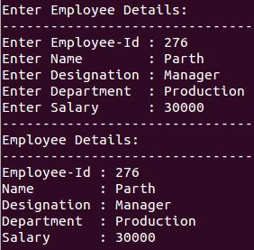

**Write C program to read the details of two workers and calculate total payment of workers using structure.**  
  
**Solution:**

#include<stdio.h>  
struct worker  
{  
     char name[20];  
     int wage;  
     int wdays;  
};  
int main()  
{  
     struct worker a,b;  
     printf("Enter Details of First Worker\n");  
     printf("-------------------------------\n");  
     printf("Enter Worker Name : ");  
     scanf("%s",a.name);  
     printf("Enter Wage        : ");  
     scanf("%d",&a.wage);  
     printf("Enter wdays       : ");  
     scanf("%d",&a.wdays);  
     printf("-------------------------------\n");  
     printf("Enter Details of Second Worker\n");  
     printf("-------------------------------\n");  
     printf("Enter Worker Name : ");  
     scanf("%s",b.name);  
     printf("Enter Wage        : ");  
     scanf("%d",&b.wage);  
     printf("Enter wdays       : ");  
     scanf("%d",&b.wdays);  
     printf("-------------------------------\n");  
     int p1=a.wage*a.wdays;  
     printf("Name of First Worker : %s\nPayment of First Worker : %d\n",a.name,p1);  
     printf("-------------------------------\n");  
     int p2=b.wage*b.wdays;  
     printf("Name of Second Worker : %s\nPayment of Second Worker : %d\n",b.name,p2);  
     return 0;  
}

**Output:**  
  
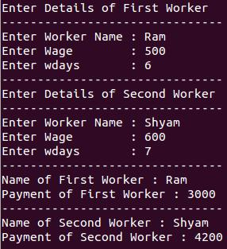

**Write C program to accept batting information of cricket team using structure. It contains player name and runs scored by player. Calculate total runs scored by cricket team.**  
  
**Solution:**

#include<stdio.h>  
struct player  
{  
     char name[20];  
     int runs;  
};  
int main()  
{  
     int i,s=0;  
     struct player a[11]; //a[11] - no. of players  
     printf("Enter Name of Player Runs Scored \n");  
     printf("---------------------------------------------\n\t");  
     for(i=0;i<=10;i++)  
     {  
          scanf("%s",a[i].name);  
          scanf("%d",&a[i].runs);  
          printf("\t");  
     }  
     for(i=0;i<=10;i++)  
          s=s+a[i].runs;  
     printf("\n---------------------------------------------\n");  
     printf("Total Runs Scored by Team: %d",s);  
     return 0;  
}

**Output:**  
  
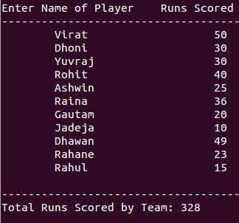

**C program to read information of student. It contains Name, Roll number, Birthday, admission date. Calculate age of student at the time of admission.**  
  
**Solution:**

#include<stdio.h>  
/*Here, we are using nested structure*/  
struct student  
{  
     int roll_num;  
     char name[20];  
     struct Date  
     {  
          int D;  
          int M;  
          int Y;  
     }bd,ad;  
};  
int main()  
{  
     int r;  
     struct student a;  
     printf("\tEnter Student Details\n");  
     printf("----------------------------------------------------\n");  
     printf("Enter Roll-Number    : ");  
     scanf("%d",&a.roll_num);  
     printf("Enter Name      : ");  
     scanf("%s",a.name);  
     printf("Enter Birth-Date     : ");  
     scanf("%d-%d-%d",&a.bd.D,&a.bd.M,&a.bd.Y);  
     printf("Enter Admission-Date : ");  
     scanf("%d-%d-%d",&a.ad.D,&a.ad.M,&a.ad.Y);  
     r=a.ad.Y-a.bd.Y;  
     printf("----------------------------------------------------\n");  
     printf("\nApproximate Age of Student at the Time of Admission\n");  
     printf("----------------------------------------------------\n");  
     printf("\t%d Years",r);  
     return 0;  
}

**Output:**  
  
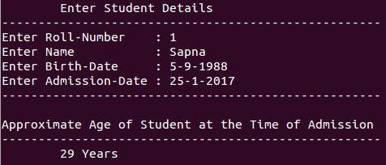

**Write a 'C' program to accept customer details such as: Account_no, Name, Balance using structure. Assume 3 customers in the bank. Write a function to print the account no. and name of each customer whose balance < 100 Rs.**  
  
**Solution:**

#include<stdio.h>  
/* Defining Structre*/  
struct bank  
{  
     int acc_no;  
     char name[20];  
     int bal;  
}b[3];  
/*Function to find the details of customer whose balance < 100.*/  
void check(struct bank b[],int n) /*Passing Array of structure to function*/  
{  
     int i;  
     printf("\nCustomer Details whose Balance < 100 Rs. \n");  
     printf("----------------------------------------------\n");  
     for(i=0;i<n;i++)  
     {  
          if(b[i].bal<100)  
          {  
               printf("Account Number : %d\n",b[i].acc_no);  
               printf("Name           : %s\n",b[i].name);  
               printf("Balance        : %d\n",b[i].bal);  
               printf("------------------------------\n");  
          }  
     }  
}  
int main()  
{  
     int i;  
     for(i=0;i<3;i++)  
     {  
          printf("Enter Details of Customer %d\n",i+1);  
          printf("------------------------------\n");  
          printf("Enter Account Number : ");  
          scanf("%d",&b[i].acc_no);  
          printf("Enter Name           : ");  
          scanf("%s",b[i].name);  
          printf("Enter Balance        : ");  
          scanf("%d",&b[i].bal);  
          printf("------------------------------\n");  
     }  
     check(b,3);           //call function check  
     return 0;  
}

**Output:**  
  
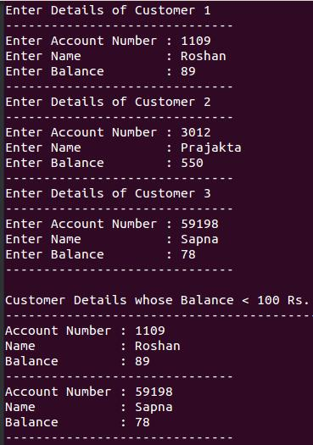

**Write a C program to accept details of 'n' employee(eno, ename, salary) and display the details of employee having highest salary. Use array of structure.**  
  
**Solution:**

#include<stdio.h>  
struct employee  
{  
     int eno;  
     char ename[20];  
     int salary;  
}emp[10];  
int main()  
{  
     int i,high,n;  
     printf("/*How many employee info\nyou want to accept : ");  
     printf("Enter Limit: ");  
     scanf("%d",&n);  
     printf("-----------------------------\n");  
     printf("Enter details for %d employees:",n);  
     printf("\n-----------------------------\n");  
     for(i=0;i<n;i++)  
     {  
          printf("Employee Number: ");  
          scanf("%d",&emp[i].eno);  
          printf("Name           : ");  
          scanf("%s",emp[i].ename);  
          printf("Salary         : ");  
          scanf("\n %d",&emp[i].salary);  
          printf("-----------------------------\n");  
     }  
     high=emp[0].salary;  
     for(i=0;i<n;i++)  
     {  
          if(emp[i].salary>high)  
          high=emp[i].salary;  
     }  
     printf("Highest salary employee details:");  
     printf("\n-----------------------------\n");  
     printf("EMPNO    NAME  SALARY\n");  
     for(i=0;i<n;i++)  
     {  
          if(emp[i].salary==high)  
          printf("\n %d\t%s\t%d",emp[i].eno,emp[i].ename,emp[i].salary);  
     }  
     return 0;  
}

**Output:**  
  
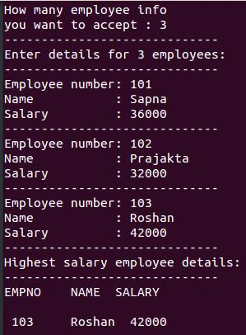

**Write a menu driven program in 'C' which shows the working of library. The menu option should be  
  
i) Add book details.  
ii) Display book details.  
iii) List all books of given author.  
iv) List the count of books in the library.  
v) Exit.**  
  
**Solution:**

#include<stdio.h>  
#include<stdlib.h>  
#include<string.h>  
struct book  
{  
     int  b_no;  
     char b_name[40];  
     char b_author[40];  
     int  no_pages;  
};  
int main()  
{  
     struct book b[20];  
     int    ch,n,i,count = 0;  
     char   temp[40];  
     do  
     {  
          printf("\t\tMENU");  
          printf("\n-------------------------------------\n");  
          printf("PRESS 1.TO ADD BOOK DETAILS.");  
          printf("\nPRESS 2.TO DISPLAY BOOK DETAILS.");  
          printf("\nPRESS 3.TO DISPLAY BOOK OF GIVEN AUTHOR.");  
          printf("\nPRESS 4.TO COUNT NUMBER OF BOOKS.");  
          printf("\nPRESS 5.TO EXIT.");  
          printf("\n-------------------------------------\n");  
          printf("Enter Your Choice: ");  
          scanf("%d",&ch);  
          switch(ch)  
          {  
               case 1:  
                    printf("\nHow Many Records You Want to Add: ");  
                    scanf("%d",&n);  
                    printf("-------------------------------------\n");  
                    printf("Add Details of %d Book\n",n);  
                    printf("-------------------------------------\n");  
                    for(i = 0 ; i < n ; i++)  
                    {  
                         printf("Enter Book No.     : ");  
                         scanf("%d",&b[i].b_no);  
                         printf("Book Name          : ");  
                         scanf("%s",b[i].b_name);  
                         printf("Enter Author Name  : ");  
                         scanf("%s",b[i].b_author);  
                         printf("Enter No. of Pages : ");  
                         scanf("%d",&b[i].no_pages);  
                         printf("-------------------------------------\n");  
                    }  
                    break;  
               case 2:  
                    printf("\n\t\tDetails of All Book");  
                    printf("\n-----------------------------------------------------------\n");  
                    printf("Book No.   Book Name\t  Author Name\tNo. of Pages");  
                    printf("\n------------------------------------------------------------");  
                    for( i = 0 ; i < n ; i++)  
                    {  
                         printf("\n %d\t  %s\t  %s\t  %d",b[i].b_no,b[i].b_name,b[i].b_author,b[i].no_pages);  
                    }  
                    printf("\n\n");  
                    break;  
             case 3:  
                    printf("\nEnter Author Name: ");  
                    scanf("%s",temp);  
                    printf("--------------------------------------");  
                    for( i = 0 ; i < n ; i++)  
                    {  
                         if(strcmp(b[i].b_author,temp) == 0)  
                         {  
                              printf("\n%s\n",b[i].b_name);  
                         }  
                    }  
                    break;  
               case 4 :  
                    for( i = 0 ; i < n ; i++)  
                    {  
                         count++;  
                    }  
                    printf("\nTotal Number of Books in Library : %d\n",count);  
                    printf("-----------------------------------------\n");  
                    break;  
               case 5 :  
                    exit(0);  
          }  
     }while(ch != 5);  
     return 0;  
}

**Output-1**  
  
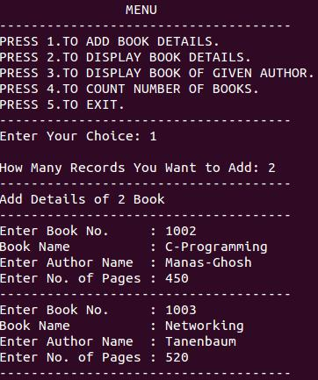  
  
**Output-2**  
  
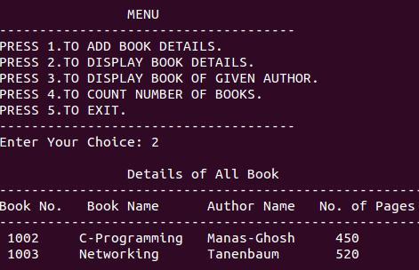  
  
**Output-3**  
  
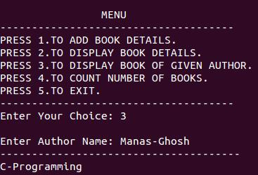  
  
**Output-4**  
  
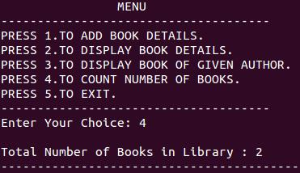

**Write a 'C' Program to create a structure of student having fields roll_no, stud_name, mark1, mark2, mark3. Calculate total marks and average marks. Arrange the records in descending order of marks.**  
  
**Solution:**

#include<stdio.h>  
struct student  
{  
     int rno;  
     char name[20];  
     int marks[3];  
     int total;  
     float avg;  
}stud[2];  
int main()  
{  
     int i,j;  
     struct student s;  
     for(i=0;i<2;i++)  
     {  
          printf("Enter Record for Student-%d \n",i+1);  
          printf("-----------------------------------\n");  
          printf("Enter Roll-No. : ");  
          scanf("%d",&stud[i].rno);  
          printf("Enter Name     : ");  
          scanf("%s",stud[i].name);  
          stud[i].total=0;  
          for(j=0;j<3;j++)  
          {  
               printf("Enter Marks of Subject %d : ",j+1);  
               scanf("%d",&stud[i].marks[j]);  
               stud[i].total=stud[i].total+stud[i].marks[j] ;  
               stud[i].avg=stud[i].total/3.0;  
          }  
          printf("\n-----------------------------------\n");  
     }  
     for(i=0;i<2;i++)  
     {  
          for(j=i+1;j<2;j++)  
          {  
               if(stud[i].total<stud[j].total)  
               {  
                    s=stud[i];  
                    stud[i]=stud[j];  
                    stud[j]=s;  
               }  
          }  
     }  
     printf("Records in Descending Order.\n (According to Total-Marks)");  
     printf("\n-----------------------------------\n");  
     printf("\n ROLLNO   NAME  TOTAL-MARKS  AVG\n");  
     for(i=0;i<2;i++)  
     {  
          printf("\n %d\t %s\t %d\t %.2f",stud[i].rno,stud[i].name,stud[i].total,stud[i].avg);  
     }  
     return 0;  
}

**Output:**  
  
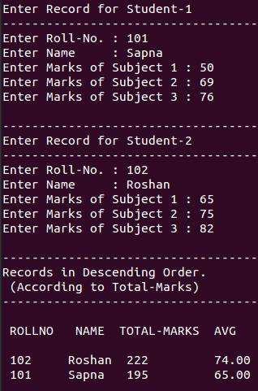

**Write a 'C' program to accept book details for 'n' books as book_title, author, publisher and cost. Assign the accession number to each book in increasing order. Display these details as,  
  
1. Books of a specific author  
2. Books by a specific Publisher  
3. All Books costing Rs. 500 and above.  
4. All Books.**  
  
**Solution:**

#include<stdio.h>  
#include<string.h>  
#include<stdlib.h>  
struct book  
{  
     int bno,bcost,baccno;  
     char bname[20],bpub[20],bauthor[20];  
}p[10];  
int main()  
{  
     int n,i,ch;  
     char pubname[20],authorname[20];  
     printf("/*How Many Records of Books You Want to Add*/\n\nEnter Limit : ");  
     scanf("%d",&n);  
     printf("------------------------------------------\n");  
     for(i=0;i<n;i++)  
     {  
          printf("\tEnter Details of Book-%d",i+1);  
          printf("\n------------------------------------------\n");  
          printf("Book Number      : ");  
          scanf("%d",&p[i].bno);  
          printf("Book Name        : ");  
          scanf("%s",p[i].bname);  
          printf("Author Name     : ");  
          scanf("%s",p[i].bauthor);  
          printf("Publication : ");  
          scanf("%s",p[i].bpub);  
          printf("Cost             : ");  
          scanf("%d",&p[i].bcost);  
          printf("Accession Number : ");  
          scanf("%d",&p[i].baccno);  
          printf("------------------------------------------\n");  
     }  
     while(1)  
     {  
          printf("\n\t\tMENU\n");  
          printf("------------------------------------------\n");  
          printf("\n1.Books of Specific Author");  
          printf("\n2.Books of Specific Publisher");  
          printf("\n3.All Books Costing Rs. 500 & Above");  
          printf("\n4.All Books");  
          printf("\n5.Exit");  
          printf("\n------------------------------------------\n");  
          printf("\nEnter Your Choice : ");  
          scanf("%d",&ch);  
          printf("\n");  
          switch(ch)  
          {  
               case 1:  
                    printf("Enter Author Name : ");  
                    scanf("%s",authorname);  
                    for(i=0;i<n;i++)  
                    {  
                         if(strcmp(p[i].bauthor,authorname)==0)  
                         printf("\nBook Number      : %d\nBook Name        : %s\nAccession Number : %d\n",p[i].bno,p[i].bname,p[i].baccno);  
                    }  
                    break;  
               case 2:  
                    printf("Enter Publication Name : ");  
                    scanf("%s",pubname);  
                    for(i=0;i<n;i++)  
                    {  
                         if(strcmp(p[i].bpub,pubname)==0)  
                              printf("\nBook Number      : %d\nBook Name        : %s\nAccession Number : %d\n\n",p[i].bno,p[i].bname,p[i].baccno);  
                    }  
                    break;  
               case 3:  
                    for(i=0;i<n;i++)  
                    {  
                         if(p[i].bcost>=500)  
                         {  
                              printf("Book Number : %d\n",p[i].bno);  
                              printf("Book Name : %s \n",p[i].bname);  
                              printf("Cost : %d\n",p[i].bcost);  
                              printf("Accession Number : %d\n",p[i].baccno);  
                              printf("\n------------------------------------------\n");  
                         }  
                    }  
                    break;  
               case 4:  
                    for(i=0;i<n;i++)  
                    {  
                         printf("Book Number   : %d\n",p[i].bno);  
                         printf("Book Name : %s \n",p[i].bname);  
                         printf("Author : %s\n",p[i].bauthor);  
                         printf("Publisher : %s\n",p[i].bpub);  
                         printf("Cost : %d\n",p[i].bcost);  
                         printf("Accession Number : %d\n",p[i].baccno);  
                         printf("\n------------------------------------------\n");  
                    }  
                    break;  
               case 5:  
                    exit(0);  
          }  
     }  
     return 0;  
}

**Output-1**  
  
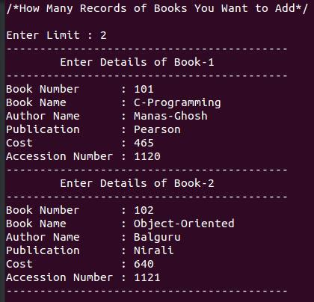  
  
**Output-2**  
  
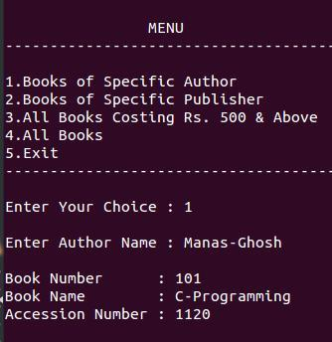  
  
**Output-3**  
  
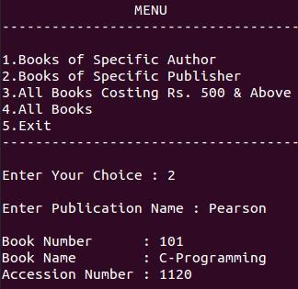  
  
**Output-4**  
  
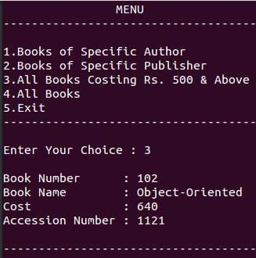  
  
**Output-5**  
  
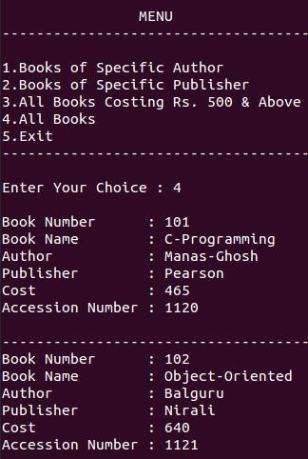

**Write a C-program to create student structure having field roll_no, stud_name, class. Pass this entire structure to function and display the structure elements.**  
  
**Solution:**

#include<stdio.h>  
struct stud  
{  
     int roll_no;  
     char stud_name[20];  
     int std;  
}s;  
void student(struct stud s)  
{  
     printf("Student details:\n");  
     printf("--------------------------\n");  
     printf("Roll Number : %d",s.roll_no);  
     printf("\nName        : %s",s.stud_name);  
     printf("\nStd         : %d",s.std);  
}  
int main()  
{  
     printf("Enter Student Details\n");  
     printf("--------------------------\n");  
     printf("Roll Number : ");  
     scanf("%d",&s.roll_no);  
     printf("Name        : ");  
     scanf("%s",s.stud_name);  
     printf("Std.        : ");  
     scanf("%d",&s.std);  
     printf("--------------------------\n");  
     student(s);  
     return 0;  
}

**Output:**  
  
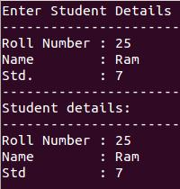

**Write a menu driven program in C to create a structure employee having fields empid, empname, salary. Accept the details of 'n' Employees from user and perform the following operations using function.  
  
- Search by Emp-Id  
- Display All  
- Display Names of Employee having Salary > 10000.**  
  
**Solution:**

#include<stdio.h>  
#include<stdlib.h>  
struct details  
{  
     char name[30];  
     int eid;  
     int salary;  
}emp[5];  
void emp_search(int r)  
{  
     int id,i;  
     printf("\nEnter Employee-Id to be Searched : ");  
     scanf("%d",&id);  
     printf("----------------------------------------\n");  
     for(i=0;i<r;i++)  
     {  
          if(emp[i].eid==id)  
          {  
               printf("Employee Id : %d",emp[i].eid);  
               printf("\nName        : %s",emp[i].name);  
               printf("\nSalary      : %d\n",emp[i].salary);  
          }  
     }  
}  
void display(int r)  
{  
     int i;  
     printf("\nList of All Employees:\n");  
     printf("-------------------------------\n");  
     printf("Emp-Id\tEmp-Name  Salary\n");  
     printf("--------------------------------\n");  
     for(i=0;i<r;i++)  
     {  
          printf("%d\t%s\t  %d\n",emp[i].eid,emp[i].name,emp[i].salary);  
     }  
}  
void greater(int r)  
{  
     int i;  
     printf("\nDetails of Employee Whose Salary > 10000\n");  
     printf("------------------------------------------------");  
     for(i=0;i<r;i++)  
     {  
          if(emp[i].salary>10000)  
          {  
               printf("\n Employee Name : %s",emp[i].name);  
               printf("\n Employee-Id   : %d",emp[i].eid);  
               printf("\n Salary        : %d\n",emp[i].salary);  
          }  
     }  
}  
int main()  
{  
     int n,i,ch;  
     printf("/*How Many Employee Record You Want to Add*/\n\nEnter Limit  : ");  
     scanf("\n %d",&n);  
     for(i=0;i<n;i++)  
     {  
          printf("-----------------------------------------");  
          printf("\n\tEnter Details of Employee-%d",i+1);  
          printf("\n-----------------------------------------");  
          printf("\nName of Employee : ");  
          scanf("%s",emp[i].name);  
          printf("Employee-Id      : ");  
          scanf("%d",&emp[i].eid);  
          printf("Salary : ");  
          scanf("%d",&emp[i].salary);  
     }  
     while(1)  
     {  
          printf("-----------------------------------------\n");  
          printf("\t\tMenu\n");  
          printf("-----------------------------------------");  
          printf("\n 1:Search Employee by E-ID");  
          printf("\n 2:List of All Employee");  
          printf("\n 3:Display Employee Name whose Salary > 10000 ");  
          printf("\n 4:Exit");  
          printf("\n----------------------------------------\n");  
          printf("Enter Your Choice : ");  
          scanf("\n %d",&ch);  
          switch(ch)  
          {  
               case 1: emp_search(n);  
               break;  
               case 2: display(n);  
               break;  
               case 3: greater(n);  
               break;  
               case 4: exit(0);  
          }  
     }  
     return 0;  
}

**Output-1**  
  
  
  
**Output-2**  
  
  
  
**Output-3**  
  
  
  
**Output-4**  
  


**Write a C program to create a student structure having fields stud_name and address. Accept the details of 'n' students, rearrange the data in alphabetical order of student name and display it.**  
  
**Solution:**

#include<stdio.h>  
#include<string.h>  
struct stud  
{  
     char name[50];  
     char add[50];  
}s[100];  
int main()  
{  
     struct stud t;  
     int i=0,j=0,n;  
     printf("/*How many student records you want to enter?*/");  
     printf("\n\nEnter Limit : ");  
     scanf("%d",&n);  
     for(i=0;i<n;i++)  
     {  
          printf("\\nEnter Student-%d Details",i+1);  
          printf("\n--------------------------\n");  
          printf("Enter Name     : ");  
          scanf("%s",s[i].name);  
          printf("Address        : ");  
          scanf("%s",s[i].add);  
     }  
     printf("\n\tData before rearrangement");  
     printf("\n-----------------------------------\n");  
     printf("Student Name\tAddress\n");  
     printf("--------------------------------------\n");  
     for(i=0;i<n;i++)  
     {  
          printf("\n%-10s\t%3s\n",s[i].name,s[i].add);  
     }  
     for(i=0;i<n;i++)  
     {  
          for(j=i+1;j<n;j++)  
          {  
               if(strcmp(s[i].name,s[j].name)>0)  
               {  
                    t=s[i];  
                    s[i]=s[j];  
                    s[j]=t;  
               }  
          }  
     }  
     printf("\n\tData after rearrangement");  
     printf("\n-----------------------------------\n");  
     printf("Student Name\tAddress\n");  
     printf("--------------------------------------\n");  
     for(i=0;i<n;i++)  
     {  
          printf("\n%-10s\t%3s\n",s[i].name,s[i].add);  
     }  
     return 0;  
}

**Output-1**  
  
  
  
**Output-2**  
  
  
  
**Output-3**  
  
